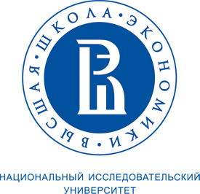 | 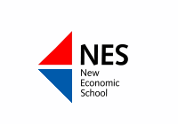

On October 19-20, 2012, the Russian Association for Studies of Higher Education will conduct its III International Conference. The special topic of this conference is “Start-up and Renewal of Universities”. The conference will be devoted to the 20-th anniversary of the National Research University - Higher School of Economics and New Economic School.
The conference will include presentations on institutional cases of the creation and radical modernization of Russian and foreign universities as well as presentations of original research papers focused on different issues in higher education.
During the conference authors will present two new comparative higher education books:
- The Road to Academic Excellence: The Making of World-Class Research Universities. Edited by Philip G. Altbach and Jamil Salmi. Washington: World Bank, 2011. (Russian edition);
- Paying the Professoriate. A Global Comparison of Compensation and Contracts. Edited by Philip Altbach, Liz Reisberg, Maria Yudkevich, Gregory Androushchak, Iván Pacheco. London: Routledge, 2012.
In the next few days conference organizing committee will issue the call or proposals.
For more information about the conference: http://rahsr.ru.

The Conference Organizing Committee.

